Article published in ‘Youth Ki Awaaz’ on 4/3/14
Link: http://www.youthkiawaaz.com/2014/03/really-mean-visually-impaired-india/

What Does It Really Mean To Be Visually Impaired In India?

By Rajkanya Mahapatra

Nancy Drew. Harry Potter. Shiny hardbound copies of Encyclopaedia Britannica, Amar Chitra Katha and a list of other books I have loved for my entire life, welcomed me when I stepped into Hall no. 12 of the World Book Fair at Pragati Maidan. I was so awestruck by the monstrosity of the place, the halls, number of books in one enclosure, under one roof. I was so happy. I expected the day to pass amidst thousands of books, peacefully, happily.
What I didn’t or wasn’t expecting was a life altering experience. It was in Hall no. 14 that my friend and I came across this booth where people were scurrying around as if they were doing something really serious, something very important, we would have walked past because we couldn’t see any books until this man came up to us and said ‘Hello, would you mind giving us 10 minutes of your time? This booth is a little workshop to spread awareness about people who are visually impaired, about the kind of technology that is enabling them to live a normal life and the concerns that have still not been addressed.’ We said yes. We registered. We were given a bookmark that had our names punched in Braille and a score card tied to our wrist. Next we were taken to a little cubicle where the volunteers put blind folds on our eyes. I couldn’t see anything.
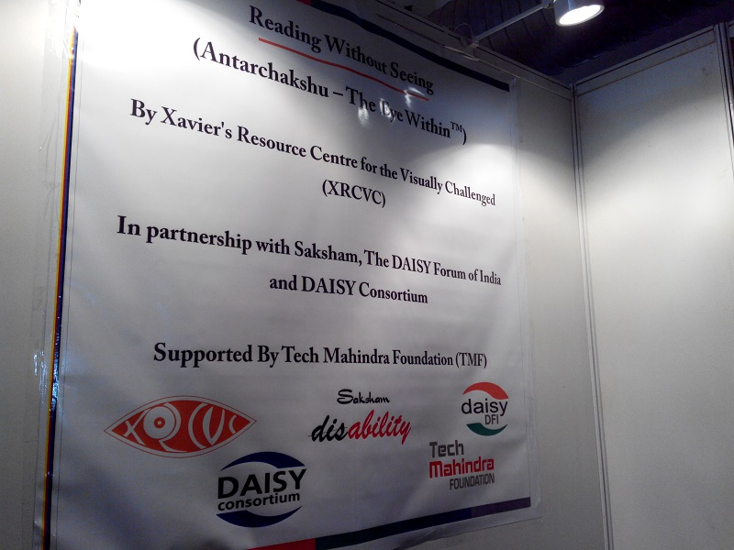
I was then handed over to this volunteer who asked me to hold his upper arm, which I did. He led me to this counter and another volunteer greeted me, she placed my hands on a sheet of paper. I could feel dots, lots of them. She asked me to recognise what shape were the dots making on the paper, it took me some time but I figured that it was a square. She added 10 points to my score card.
I was taken from one counter to another, this time I was asked to feel a note and tell them what was the denomination of the note, I ran my fingers through the note, measuring the length and the breadth trying to make pictures in my head as to ascertain if it was a 10 rupee note or a 20. I finally told them that it was a 10 rupee note and then I was given a coin, it was a one rupee coin I told them after feeling the coin for a minute. I was correct. I smiled but not being able to see for a good 5 minutes now was kind of scaring me, I didn’t know who the volunteers were, what they looked like, what the space around me looked like. The next challenge was to tell them how many dots were on this paper that I was given, this was one confusing, I couldn’t be sure until I had placed my fingers on all the three dots. I got this right too. Now came the most difficult challenge of all, I had to type my name on a keyboard and I had to get it right, thanks to the hours of typing on the laptop late at night, I knew my way around the keyboard and I got this one right too. So I got 40 on 40. I was really happy.
They took the blind folds off me. I could see light again, I could see colours, people, and friends. Relief washed over me. I thanked God over a million times for giving me the gift of sight. After exiting the workshop, I wanted to cry. But it wasn’t over just yet. The best was yet to come.
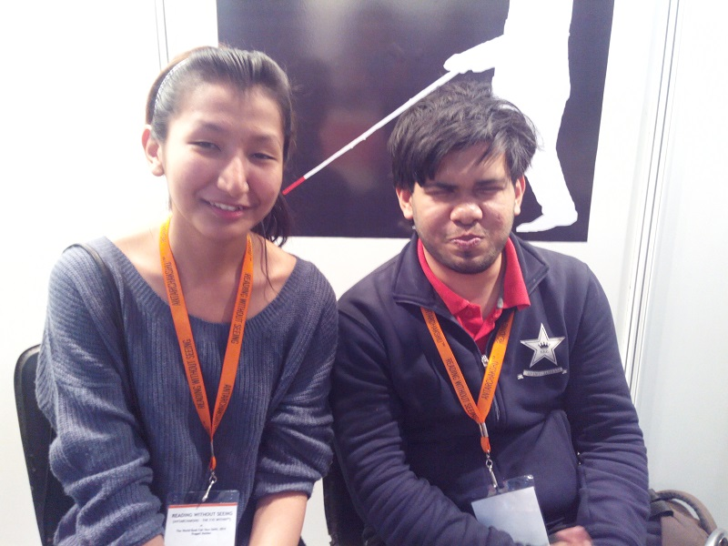
After the blind folds were taken off me, I found myself in another enclosure buzzing with volunteers and other people who had just gone through the four activities I did. I found myself staring at a computer screen, the volunteer explained that there was a software in the laptop that made it easier for visually impaired people to type on a computer, whatever they would enter would be said aloud by a robotic voice. The volunteer typed in Hello. The robotic voice replied back, h e l l o, hello. One letter at a time and then the word. This was really nice for it made it much easier for the visually impaired to use a computer. This bust a myth for me, I previously had this notion that it must be really difficult for the visually impaired to work on a computer, use technology efficiently. What came next completely stunned me, there was a scanner that would scan pages from books and read it aloud, so that the blind could read or in this case hear what makes a story. Then there was a typewriter that typed in the braille script, a chess board with braille engravings, a braille embossed watch dial, calculator, playing cards, thermometer, alarm clock, wallet that was compartmentalised in sections according to the length of the notes, sonic labeller and a pen friend, wherein you could use these ‘g’ marked stickers and put the pen friend and record an item’s name that you were going to stick it on, whenever next you wanted access to that item all you had to do was roll the pen over the container and when the pen touched the sticker it would say the name of the item aloud.
I’ll tell you why this experience deeply saddened me. It upset me because we are so ignorant about things. How we forget what constitutes people, how quickly we denigrate people who are different from us to the ranks of animals (in reference to the Section 377 debate) or do not care about them at all. Our nonchalance is hurting an entire section of the population, in the context of the book fair, an entire section that just happens to read differently than we do.
Antar-chakshu is a simulated workshop aimed at creating a sneak preview for the sighted into the worlds of the visually impaired. The objective of the module is to equip us with insight and understanding.
I am glad that something like this happened to me. That Antar Chakshu happened to me. Antar Chakshu is organised by The Xavier’s Resource Centre for the Visually Challenged, Mumbai. It is an organisation that works actively in the field of creating Print Access as well as Awareness Generation on this subject. XRCVC has partnered with Saksham Trust which is a charitable trust that empowers persons belonging to the marginalized sections of society. Also XRCVC has support from the Daisy Forum of India (DFI) which is an umbrella body of over 90 organisations working to promote print access for the print disabled in India, and the Daisy Consortium, which is a global consortium of organisations committed to a common vision and mission, which pools and coordinates resources to deliver global change of making all the publications accessible to print-disabled, and works towards creating the best way to read and publish. Antar Chakshu also has support from the Tech Mahindra Foundation (TMF).
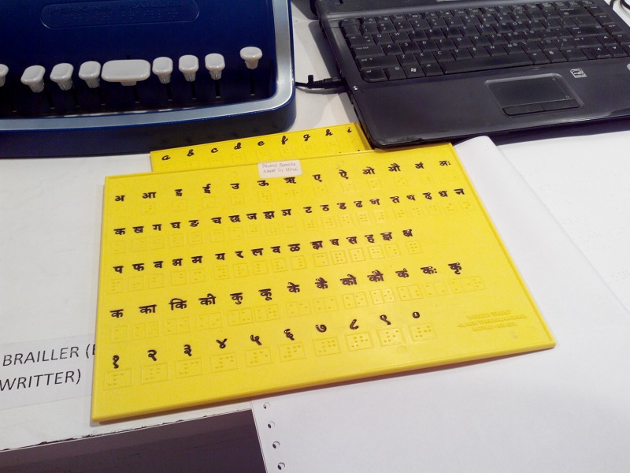
It was after the workshop that I got to meet Mayank Sharma, 2nd year student at St.Stephen’s College pursuing his Bachelor’s Degree in English. He is visually challenged but confident nevertheless, his hand shake communicated that there was nothing we should be afraid of asking him. We asked him a couple of questions like how he functions in his day to day life for it seems to us as a task very difficult, to be able to not see and function just as efficiently. He told us all about the various technologies that helps him to function. He blushed when I asked him if he had a Facebook account, to which he said he did. It was a very interesting conversation that ensued. He told us how he uses his laptop to take notes in the class and how his favourite books would be the Harry Potter series.
This article aims to encapsulate an account. An account that I lived through and how I was sensitised a notch more than I was before I being a part of this simulated workshop. This article aims to bring to you a very noble effort calledAntar Chakshu. This article aims and urges people to get to know more about how physically challenged people survive in a not so friendly country for the physically challenged like India.
This is what Dr.Sam Taraporevala, The Director of XRCVC and the Head of the Sociology Department at St.Xavier’s College, Mumbai had to say, when I asked him what is it that he would like the people to know – “Given the right opportunities, barriers can be broken, so there is this whole ‘Print Divide’ which is the result of confining print access to ‘sighted’ content. The root of all content today is essentially electronic and digital, so if this content can be made available to a print disable person, they are going to be able to reach a wider audience, in terms of the youth, the message is essentially that there are no boundaries, one need to think beyond boundaries to find solutions. So, disability is more environmentally defined rather than physical or sensory or cognitive. So it is the environment which is disabling because if we build the right environment, you will automatically create the conducive situation.”

