Life of Visually Challenged Physiotherapist student’s made easy
Posted on March 21st, 2011
Posted by aloke
Archived in Featured, Mumbai / मुंबई
Leave a comment

Tags

Previous Post
Nothing impossible for a woman

Next Post
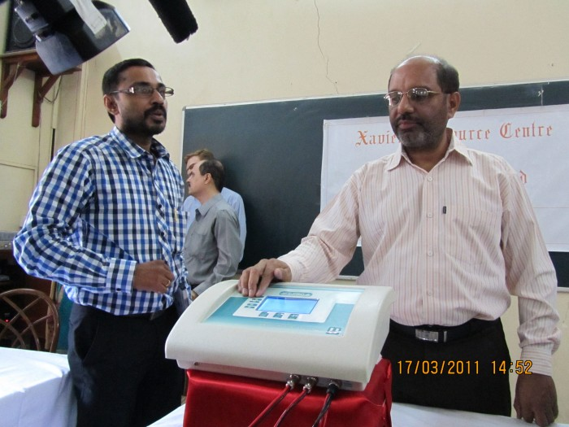
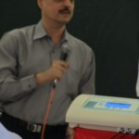
Dr.Sam Taraporevala with the machine
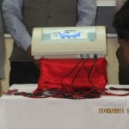
IFT -Pro
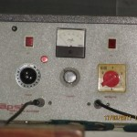
Prototype of Short Wave Machine Diathermy

Mumbai: Students of Physiotherapy can now learn faster and better with the aid of a machine that have been launched by the Xavier’s Resource Centre for the Visually Challenged (XRCVC). These students can now complete their five year course with the aid of a talking electrotherapy machine.
On Thursday 17th March, XRCVC brought to light this machine called the IFT-Pro (Inferential therapy cum Electro muscle stimulator cum TENS). This machine has been available in the market for the past four years with four therapies like pain relief and treatment for paralysis. Speech component has been added as an additional feature to this machine by XRCVC at no additional cost.
The machine when switched on reads out an audio message. It also reads out information displayed on the screen and provides audio instructions as and when any key is pressed.
Since the last century, visually challenged people have been practicing Physiotherapy as a profession the world over and in India. But due to inappropriate facilities these professionals were sidelined for many years. With the change in time there has also been technological advancement which in turn has proved to be beneficial for the visually challenged.
“This development highlights the fact that where there is a will, there is a way. We appreciate the commitment of these manufacturers who have built accessibility into their mainstream systems. We hope that other manufacturers including those making electronic goods will also take the necessary proactive steps and become manufacturers for who accessibility is a mantra. In the absence of an accessible therapy machine, visually challenged students opt for diploma and certificate courses rather than degree courses. The inclusion of the speech component would help them turn the profession into a successful career opportunity” said Dr. Sam Taraporevala, head XRCVC.
“It has always been my dream that my Electro physiotherapy equipment would become accessible, as in case of my laptop and mobile phone. The accessibility in my Electrotherapy equipments shall now allow me to perform even better in my practice, and has also relieved me of cramming long menus in the new digital equipments. It shall also allow the visually impaired to explore new treatment options in trend with the latest treatment regimes” said Dr. Homiyar Mobedji, consulting physiotherapist who has been practicing for the past 26 years.
XRCVC also launched a prototype of Short Wave Diathermy machine; it is used to give deep tissue heating. With the use of this machine, the students can see the deflection of the meter after turning on the machine which was not possible earlier as knobs had to be used for the same.
Dr. Mobedji said, “An audio-visual component has been added to the machine. People who are completely blind can rely on the audio whereas people with low vision can make use of the LED screen.”
By Farheen Siddiqui
http://citizensreport.in/2011/03/life-of-visually-challenged-physiotherapist-student%e2%80%99s-made-easy/

